E-Commerce Funnel & Profitability Analysis
Project Documentation | Prepared by: Nijamoddin | Tools: Python (Pandas, Matplotlib, Seaborn, SciPy), Power BI | Data period: 19 Mar 2012 – 19 Mar 2015

1. Project Overview
This project analyses three years of activity for an online toy retailer selling four products. The goal was to identify where customers drop off, which channels and products drive growth, and how refunds affect profit. Data was cleaned and analysed in Python, then presented in a three-page Power BI dashboard.
Headline KPIs
Metric | Value
Total revenue (before refunds) | $1.94M
Total orders | 32.31K
Website sessions | 472.87K
Overall conversion rate | 6.83%
Average order value | $59.99
Total refunds | $85,338.69 (4.40% of revenue)

2. Data Sources and Cleaning
Six tables were used: website_sessions (472,871 rows), website_pageviews (1,188,124), orders (32,313), order_items (40,025), order_item_refunds (1,731) and products (4). Relationships: sessions → pageviews and orders → order items → products and refunds.
Cleaning steps
- Converted all created_at fields from text to datetime across the six tables.
- Checked duplicates and missing values: no duplicate rows or duplicate session IDs were found.
- Found 83,328 sessions (17.62%) with no UTM data and labelled them “Unattributed”. Of these, 43,411 carried a gsearch or bsearch referrer, so they are likely untagged search traffic; 39,917 have no referrer at all (likely direct visits).
- Reviewed outliers with box plots on price, COGS, items purchased and refund amount; no records needed removal.
- Exported six validated _clean.csv files, which feed the Power BI model.

3. Key Findings

3.1 Acquisition
Channel | Sessions | Orders | Conversion
Unattributed | 83,328 | 6,118 | 7.34%
bsearch | 62,823 | 4,519 | 7.19%
gsearch | 316,035 | 21,333 | 6.75%
socialbook | 10,685 | 343 | 3.21%
gsearch delivers about two-thirds of traffic and orders. Socialbook converts at less than half the rate of every other channel.

3.2 Conversion Funnel
Stage | Sessions | Step conversion
Landing / Home | 472,871 | –
Product Browsing | 261,231 | 55.2%
Product Detail | 210,214 | 80.5%
Cart | 94,953 | 45.2%
Shipping | 64,484 | 67.9%
Billing | 52,058 | 80.7%
Purchase | 32,313 | 62.1%
The largest drop is Product Detail → Cart (54.83%). By product, the cart rate is 65.1% for Hudson River Mini Bear, 55.6% for Forever Love Bear, 46.3% for Birthday Sugar Panda and 43.0% for The Original Mr. Fuzzy. Price alone does not explain the gap, so product-page content should be reviewed.

3.3 New vs Returning Visitors
Returning visitors convert better (7.83% vs 6.64%) and earn more per session ($4.74 vs $3.97). New visitors still generate about 81% of revenue ($1.57M) because they make up 83% of sessions.

3.4 Product Performance and Profitability
Product | Revenue | Net profit | Refund rate | Net margin
The Original Mr. Fuzzy | $1.21M | $677K | 5.11% | 58.9%
The Forever Love Bear | $0.35M | $210K | 2.23% | 61.7%
The Birthday Sugar Panda | $0.23M | $143K | 6.04% | 66.5%
The Hudson River Mini Bear | $0.15M | $101K | 1.28% | 67.9%
Mr. Fuzzy is the main profit driver (75% of units sold) but has the lowest margin. Hudson River Mini Bear is the most efficient per dollar, and Birthday Sugar Panda has the most serious refund problem.
Note: Net margin = net profit ÷ net revenue (after refunds). The Power BI page shows margin on gross revenue, so its percentages are slightly lower. Net profit values match in both.

3.5 Order Value
One-item orders (76.1%) average $50.82; two-item orders (23.9%) average $89.25. Bundling is a clear lever to lift order value.

3.6 Trend and Seasonality
- Monthly sessions grew from 1,879 (Mar 2012) to 29,722 (Dec 2014), about 15.8×.
- Conversion improved from 3.19% to 8.70% (Feb 2015).
- Revenue grew roughly 150–240% year over year in every month of 2014.
- Seasonality is strong: revenue and orders dip in Apr–Aug and peak in Nov–Dec (Dec: $228K and 3.9K orders across years).
- March 2015 is a partial month (data ends 19 Mar) and is excluded from trend conclusions.

3.7 Refund Analysis
A chi-square test (χ² = 245.6, df = 3, p ≈ 5.9×10⁻⁵³) shows refund status is significantly associated with product. Cramér’s V of 0.078 indicates the association is small. Because each product has a single price, product effects cannot be separated from price effects, so causes should be investigated rather than assumed.

3.8 Acquisition Channel Conversion
Unattributed traffic has the highest reported conversion rate (7.34%), closely followed by bsearch (7.19%) and gsearch (6.75%). Socialbook is lower at 3.21%; compare traffic volume, spend and audience quality before changing investment.
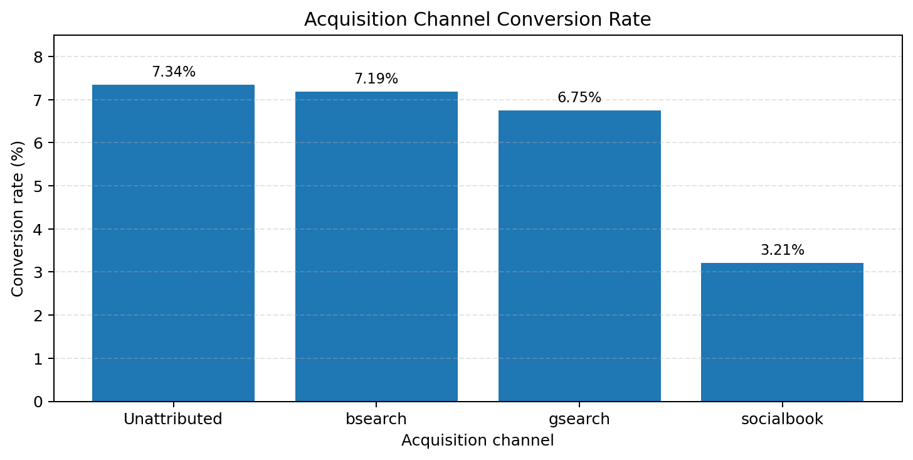
Figure: Created from the values reported in this project documentation.

3.9 Website Conversion Funnel
The largest step-level loss occurs between Product Detail (210,214 sessions) and Cart (94,953 sessions). This supports prioritizing product-page and cart-entry experiments, while validating changes with measured conversion outcomes.
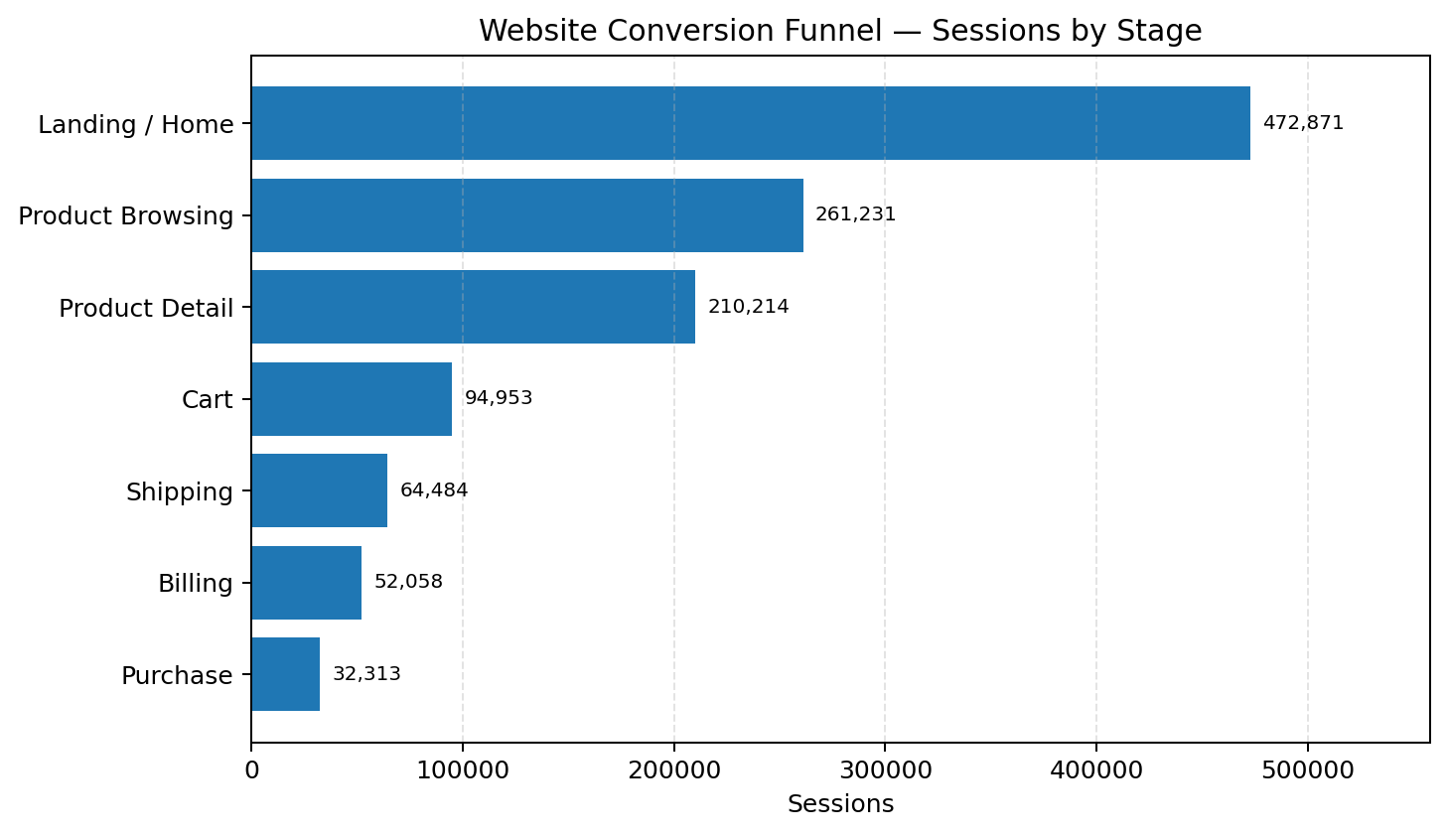
Figure: Created from the values reported in this project documentation.

3.10 Product Revenue and Net Profit
The Original Mr. Fuzzy is the largest revenue and profit contributor in the reported figures. Its scale makes it important to monitor, while margin and refund rate should be considered alongside absolute profit.
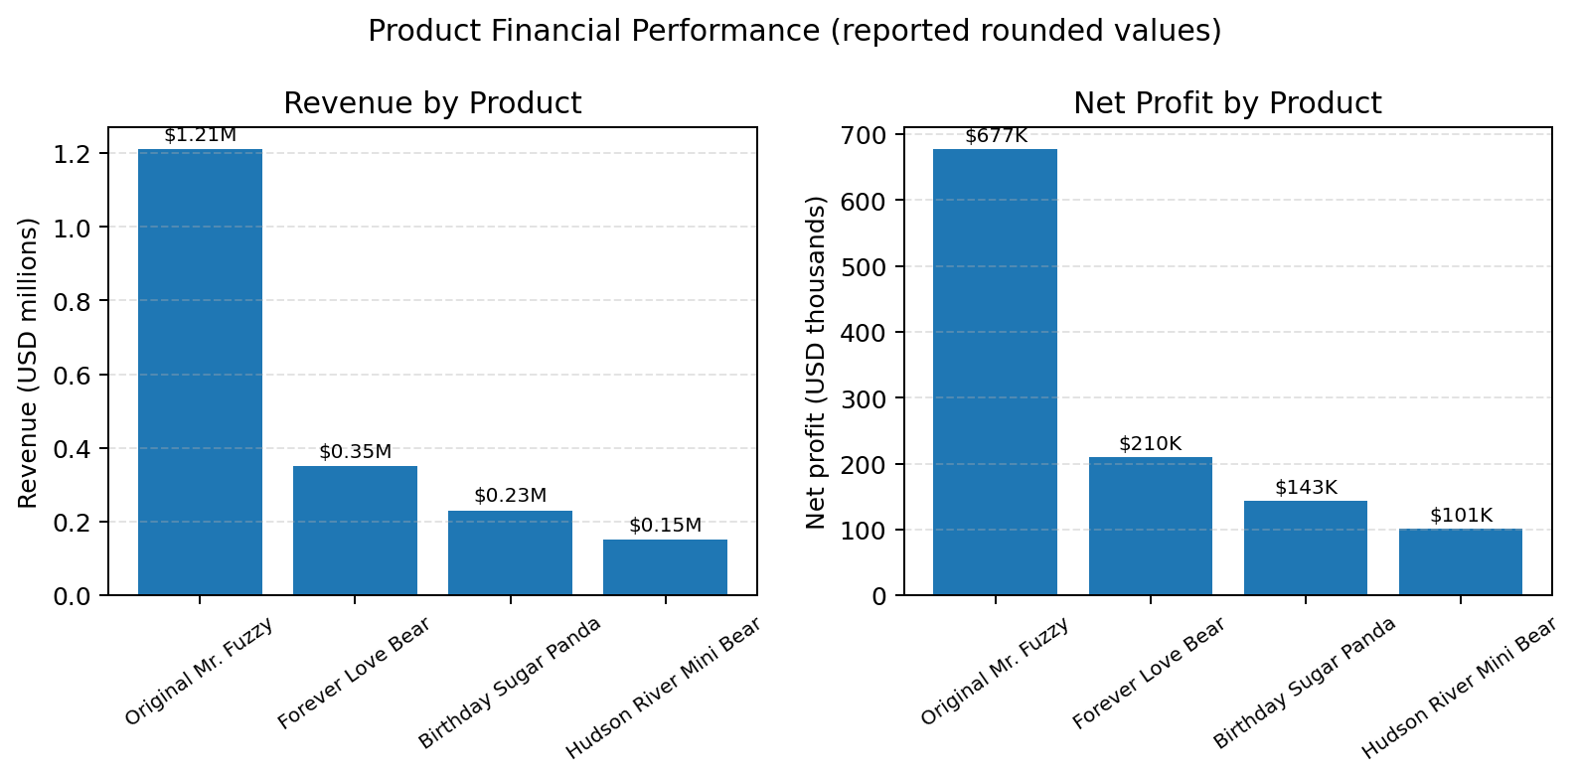
Figure: Created from the values reported in this project documentation.

3.11 Product Detail-to-Cart Conversion
Hudson River Mini Bear has the strongest reported product-detail-to-cart rate (65.1%), while The Original Mr. Fuzzy is lowest (43.0%). Review product-page content and customer expectations, and test changes rather than assuming the cause.
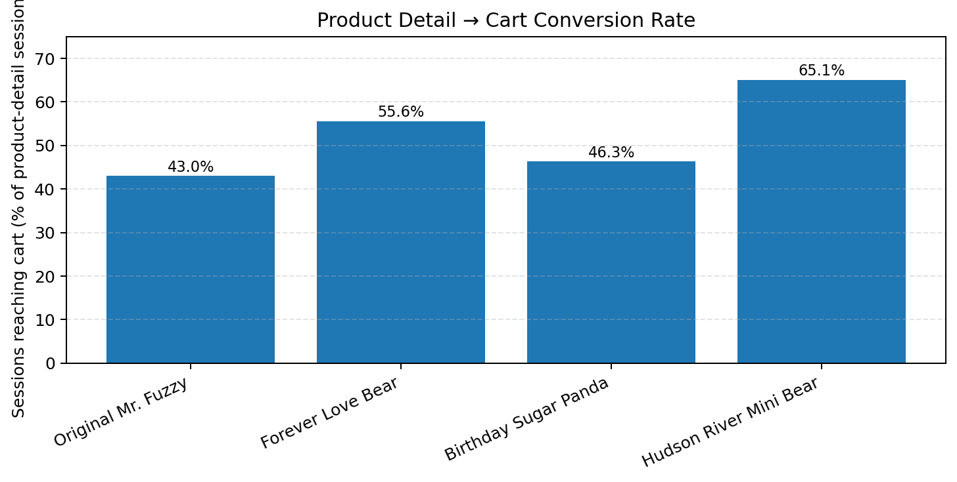
Figure: Created from the values reported in this project documentation.

4. Power BI Dashboard Summary
The dashboard has three pages with shared slicers for Year, Month and utm_source.
- Executive Overview: KPI cards, monthly revenue trend, monthly orders and net profit by product.
- Acquisition & Funnel Analysis: conversion by channel, seven-stage funnel, product detail → cart by product, and new vs returning visitors.
- Product Performance & Profitability: revenue, profit margin, orders, and revenue vs net profit by product.

5. Recommendations
- Fix the Product Detail → Cart step. Mr. Fuzzy carries 77% of product-page sessions at a 43% cart rate, so small gains here have the largest revenue impact.
- Investigate Birthday Sugar Panda refunds (6.04%): check product quality, descriptions and expectations.
- Review socialbook spend or landing experience given its 3.21% conversion.
- Promote Hudson River Mini Bear. It has the best cart rate and margin but only about 1% of product-page traffic.
- Introduce bundles or add-on offers to move one-item buyers toward two-item orders.
- Plan inventory and campaigns for Q4, and invest in retention given returning visitors’ higher conversion.
- Improve UTM tagging to reduce the 17.6% unattributed traffic.

6. Limitations
Refund and price findings show association, not causation. Hypotheses about quality, descriptions or pricing need further testing, for example through A/B tests or customer feedback.
Chart note: Product revenue and net-profit figures are rounded values copied from the existing documentation; they are intended for comparison, not reconciliation to exact totals.

